Committed with AWS secret keys and now its not running the git push origin command

For help refer:  
<https://docs.github.com/en/code-security/secret-scanning/working-with-secret-scanning-and-push-protection/working-with-push-protection-from-the-command-line#resolving-a-blocked-push>

Step1: get the commit id, it will be displayed in the error:

Now make the command with using the link provided above, step 4, it will look like this:  
git rebase -i 700e1e912982dd8042309c499be5263dffa10d7b~1

Run this on the terminal

It will open this window:  
now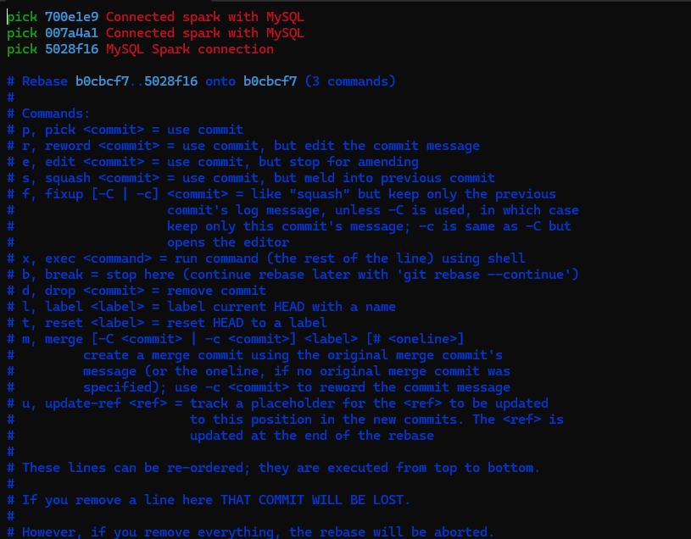

Now change the first line pick with edit

And save with:

:wq

Now run:  
git commit –amend

Will open this:  
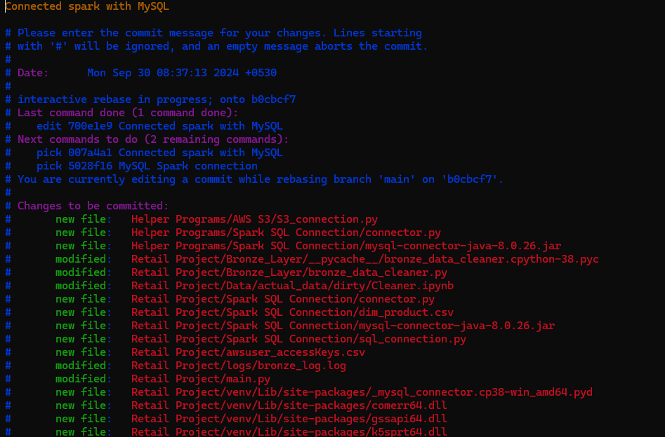

Go on the from of the file you want to remove from this commit and press ‘d’ two times

Then press esc and :wq

Then run:  
git rebase –continue

Then try your git push origin command

If still doesn’t works and you have made too many commits, then delete the file due to which its happening and reset the head to the commit before you added that files in your git

Check the logs with : git logs

Identify how many commits you have made since adding that file.

Suppose that number is 3

Then run this command:  
git reset --soft HEAD~3

It will reset the git to the 3 commits prior but won’t delete anything from your code

Now commit again and it will work